# **Name: Abdurrahman Qureshi**

# **Roll No: 210451**

Assignment 4

1. **WAP in java to perform addition of two complex numbers using different constructors**

**CODE:**

class EXP10ComplexNumber {

int realNum1;

int imaginaryNum1;

EXP10ComplexNumber(int var1, int var2) {

this.realNum1 = var1;

this.imaginaryNum1 = var2; }

EXP10ComplexNumber() {

this(0, 0); }

static void Add(EXP10ComplexNumber var0, EXP10ComplexNumber var1) {

EXP10ComplexNumber var2 = new EXP10ComplexNumber();

var2.realNum1 = var0.realNum1 + var1.realNum1;

var2.imaginaryNum1 = var0.imaginaryNum1 + var1.imaginaryNum1;

System.out.println("Result : " + var2.realNum1 + " + " + var2.imaginaryNum1 + "i"); }

void display() {

System.out.println("Result : " + this.realNum1 + " + " + this.imaginaryNum1 + "i");}

public static void main(String[] var0) {

EXP10ComplexNumber var1 = new EXP10ComplexNumber(10, 20);

EXP10ComplexNumber var2 = new EXP10ComplexNumber(5, 5);

var1.display();

var2.display();

Add(var1, var2); }}

**OUTPUT:**

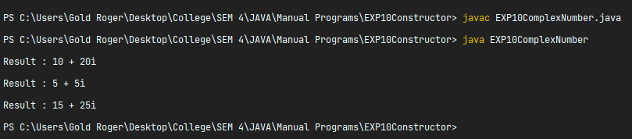

**2) WAP in java to create a class ‘Book’. Make a default constructor to initialize default values and data members. Accept and display for 1 book. Take suitable data members**

**CODE:**

import java.util.Scanner;

public class EXP10ConstructorBook {

Scanner sc;

int price;

String name;

String author;

EXP10ConstructorBook() {

this.sc = new Scanner(System.in);

System.out.print("Enter price of the EXP10ConstructorBook:");

this.price = this.sc.nextInt();

this.sc.nextLine();

System.out.print("Enter name of the EXP10ConstructorBook:");

this.name = this.sc.nextLine();

System.out.print("Enter author of the EXP10ConstructorBook:");

this.author = this.sc.nextLine();

System.out.println("Price of the EXP10ConstructorBook is " + this.price + "$");

System.out.println("Name of the EXP10ConstructorBook is " + this.name);

System.out.println("Author of the EXP10ConstructorBook is " + this.author); }

public static void main(String[] var0) {

new EXP10ConstructorBook();}}

**OUTPUT:**

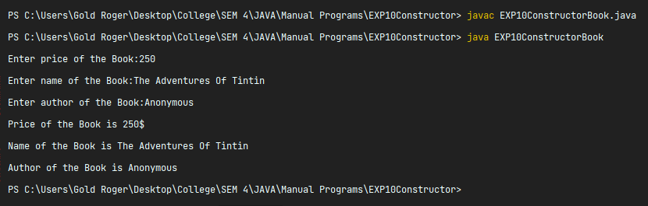

1. **WAP in java to create a class ‘student’. Make use of parameterized constructor to create 1 object and display it.**

**CODE:**

class EXP10ConstructorStudent {

String name;

int rollno;

EXP10ConstructorStudent(int var1, String var2) {

this.rollno = var1;

this.name = var2;

System.out.println("Name = " + this.name);

System.out.println("Rollno = " + this.rollno); }

public static void main(String[] var0) {

new EXP10ConstructorStudent(210451, "Dawg Qureshi");}}

**OUTPUT:**

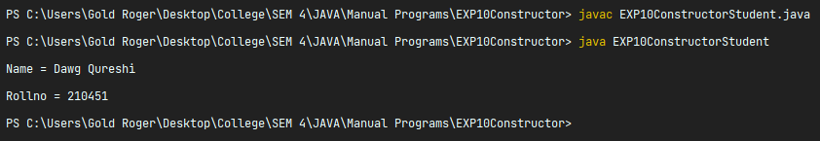

1. **WAP in java to create a class ‘vehicle’. Make use of constructor with copy constructor. Accept and display for one object.**

**CODE:**

class EXP10ConstructorVehicle {

String name;

int rollno;

EXP10ConstructorVehicle(int var1, String var2) {

this.rollno = var1;

this.name = var2; }

EXP10ConstructorVehicle(EXP10ConstructorVehicle var1) {

this.name = var1.name;

this.rollno = var1.rollno;

System.out.println("Model = " + this.name);

System.out.println("Plate Number = " + this.rollno); }

public static void main(String[] var0) {

EXP10ConstructorVehicle var1 = new EXP10ConstructorVehicle(3035, "Honda Amaze");

new EXP10ConstructorVehicle(var1); }}

**OUTPUT:**

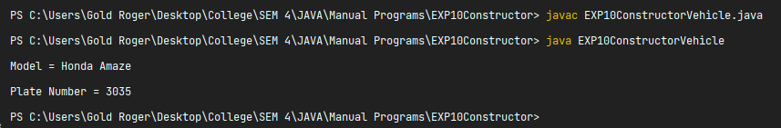

1. **WAP in java to create a class ‘Account’ having a copy constructor. Make 2 objects of same demonstrating copy constructor.**

**CODE:**

class EXP10ConstructorAccount {

int Acc_No;

String Name;

EXP10ConstructorAccount(int var1, String var2) {

this.Acc_No = var1;

this.Name = var2; }

EXP10ConstructorAccount(EXP10ConstructorAccount var1) {

this.Acc_No = var1.Acc_No;

this.Name = var1.Name; }

void display() {

System.out.println("EXP10ConstructorAccount No : " + this.Acc_No);

System.out.println("EXP10ConstructorAccount Name : " + this.Name); }

public static void main(String[] var0) {

EXP10ConstructorAccount var1 = new EXP10ConstructorAccount(210451, "Dawg");

EXP10ConstructorAccount var2 = new EXP10ConstructorAccount(var1);

System.out.println("\nOriginal Object");

var1.display();

System.out.println("\nCopied Object");

var2.display();}}

**OUTPUT:**

